Week 5 Collective Worship WC 05.12.16
A Christian Christmas- This has also been covered in each class as we prepare for our Nativity and Carol Service.
Teacher Lead- Mrs Batey | Tuesday
A Filipino Christmas  Display a Filipino nativity picture –Such scenes are called 'belen' and many homes and churches will have their own version. Talk about the Filipino nativity:  What do you like about this nativity scene and what puzzles you? What other features are particular to this part of the world?  The 'parol', a five-pointed 3D star, is a special feature of Filipino homes and shopping centres in the Christmas season. They are also carried in parades and there are competitions to make the best and most colourful. They used to have candles inside but now, for safety, they usually have an electric light at the centre. They are made from bamboo sticks and rice paper.  Remind pupils of the importance of the star in the Christmas story and of the importance of not giving up even when things are difficult as they were for the Wise Men who were following the star | 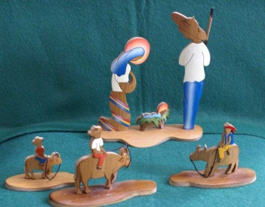  Children thought that the Nativity Scene from the Philippines reflected their culture and the nature.
Questions and thoughts from the children  Children from Class 5 related the colour around Mary’s head to being a rainbow- We have recently looked at Jesus as the light of the world- rainbow is a sign of sunshine after the rain. Link to previous RE lesson.  Children liked how simple it was but this is not what they recognise as ‘The Nativity Scene’ from the Christian Faith in England. | Prayer/ Words of thought  Lord Jesus Christ, your birth at  Bethlehem draws us to kneel in wonder at heaven touching earth: accept our heartfelt praise as we worship you, our Saviour and our eternal God.  Amen
Teacher Lead- Miss Bell | Wednesday
A Peruvian Christmas  A Peruvian Christmas (whole school)  Matthew 1 v 23  Display a Peruvian nativity picture - Peruvian nativity scenes are known as 'retablos' and are very popular. This custom dates back to the time of the first Spanish missionaries who would carry small altars around with them for festival days. These gradually developed into portable boxes with saints above the altar and scenes from everyday life below it. Now the retablos depict Mary, Joseph and baby Jesus, with local people crowding around.  Talk about the picture  The first missionaries to Peru taught the people to call Jesus 'Emmanuel', which means 'God with us'. The fact that God chose to become a person and to live a human life with all its pains and troubles is a key part of Christian teaching, and this seems to have made a deep impression on the Native American Indians. They had once been a proud people with their wealthy Inca Empire but were now conquered, so a God who comes alongside ordinary, lowly people was a God they could believe in. | What do you like about this nativity set and what puzzles you?  Pottery nativity figures are very common in Peru. Why do you think it is important that they are painted so brightly?  Families in Peru often make or buy new figures for their nativity sets. Who from everyday life in your part of the world today would you include? What do you think this has to do with Christmas?  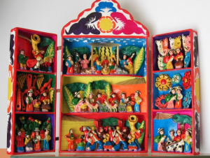
Questions and thoughts from the children  Children particularly liked the colourful Nativity Scene from Peru.  They are brightly coloured because they are important, it is a time of celebration, we should we full of joy and cheer at this time of year. | Prayer/ Words of thought  May the joy of the angels,  the eagerness of the shepherds,  the perseverance of the wise men,  the obedience of Joseph and Mary, and the peace of the Christ-child  be ours this Christmas and for evermore. Amen
Teacher Lead- Class 5 | Thursday
Joy to the World  What does Christmas mean to you?  Volunteers hunted around the room for the Christian symbols.  Symbols included: candle, wreath, present, shepherd, candy cane, lights, Kings, star | The music was cheerful and the children made every effort to try and sing along.  Joy to the World- Words were provided on IWB and Mr Walker accompanied us with his guitar.
Questions and thoughts from the children  Volunteers explained to the rest of the school the significance of the symbols.  They were confident in their responses and showed a good understanding of the true meaning of Christmas. | Prayer/ Words of thought  May we be blessed with the spirit of the season,  which is peace,  The gladness of the season,  which is hope,  And the heart of the season,  which is love. Amen
Teacher Lead- Book Awards | Friday
Questions and thoughts from the children | Prayer/ Words of thought

