Class 6 Summer 1

**French**

In French, we plan to revisit conversational French, increase numbers and look at the names of places that can be found and how to ask for and understand directions

**Science**

Miss Bingham and I will continue to deliver the two Science units we started last term. The children that were in Class 5 are learning about the human circulatory system and the impact diet, exercise, drugs and lifestyle may have on health. Those children that were in Class 6, will be looking at Earth and Space.

Within topic, we will be teaching areas of the Living Thing and their Habitats unit. Life cycle work will be taught in terms of animals of the rainforest to ensure good coverage for the Year 5s.

**Rainforests**

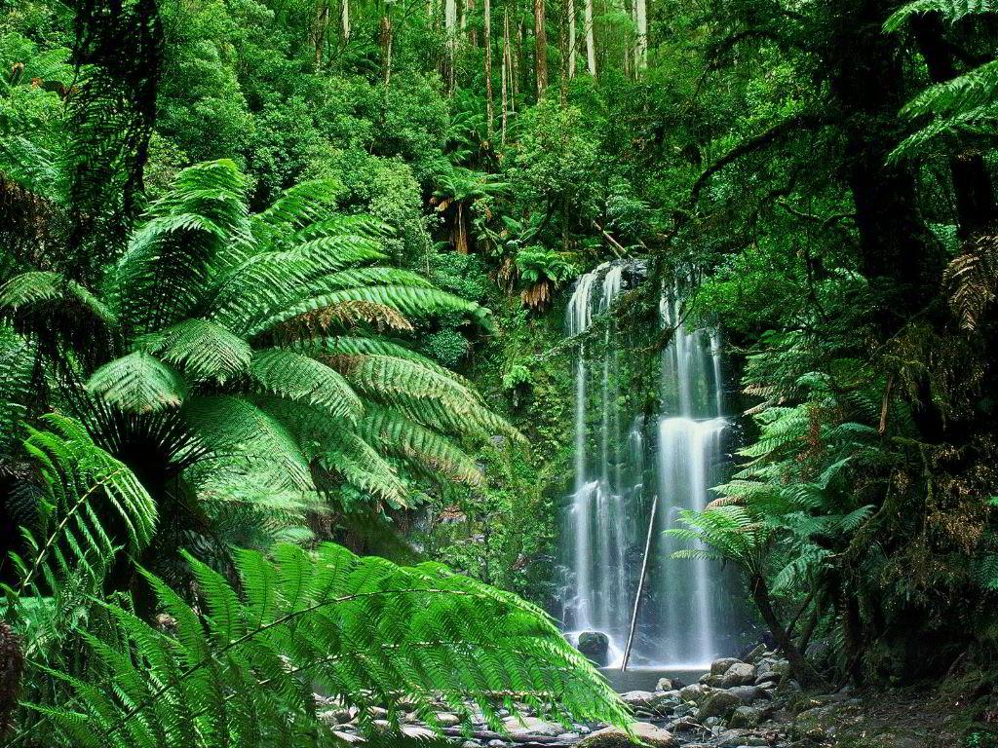

Note: All of these activities are suggested and what we hope to cover over the course of this half term.

RE/SMSC/British Values/PSHE

We are supporting an initiative endorsed by the city council called Rubbish Rebels. These lessons should promote the children’s understanding of the impact we can have on our environment.

Until Easter, we will continue to discuss how Jesus’ sacrifice through crucifixion affects Christians today.

After the bank holiday weekend, we shall consider why the Holy Spirit is important to Christians and look at Pentecost.

**English**

In English, we will be using our knowledge of deforestation to present contrasting views in a persuasive letter. Skills that will be revisited include using punctuation to avoid ambiguity and using semi colons and colons to separate main clauses. Formal language and standard English is needed to write a letter of this style. This is something the children can find quite hard to master.

In reading sessions, we will be looking into the cultural context of The Shaman’s Apprentice alongside articulating and justifying our opinions about a text and an author’s viewpoint. Journey to The River Sea will be used to help us improve our inference and deduction skills and encompassing what we find into PEE paragraphs.

**Geography**

In Geography, the children will be locating rainforests of the world. They will learn more about the structure of a rainforest and the rainforest’s importance in terms of both the immediate habitat and the world beyond.

The positive and negative consequences of deforestation will be taught and debated. Furthermore, they will learn about the products from the rainforests that we buy as consumers.

**Maths**

This half term, Year 6 will be looking at mean as well as ratio and proportion. They will learn more about the volume of shapes and liquid. Meanwhile, Year 5 will be consolidating their knowledge of decimals, place value and calculations using fractions.

The whole class will be revisiting equivalent fractions and simplification, particularly in terms of percentages and fractions of shapes.

**Art/Design**

Year 5 (and some members of Year 6) have produced some art inspired by the rainforest. Also, the whole class will do some block printing and overprinting based using the plants and animals of the rainforest as inspiration.

We never got to make our Brazilian salsa so we hope to get the opportunity to make this too.