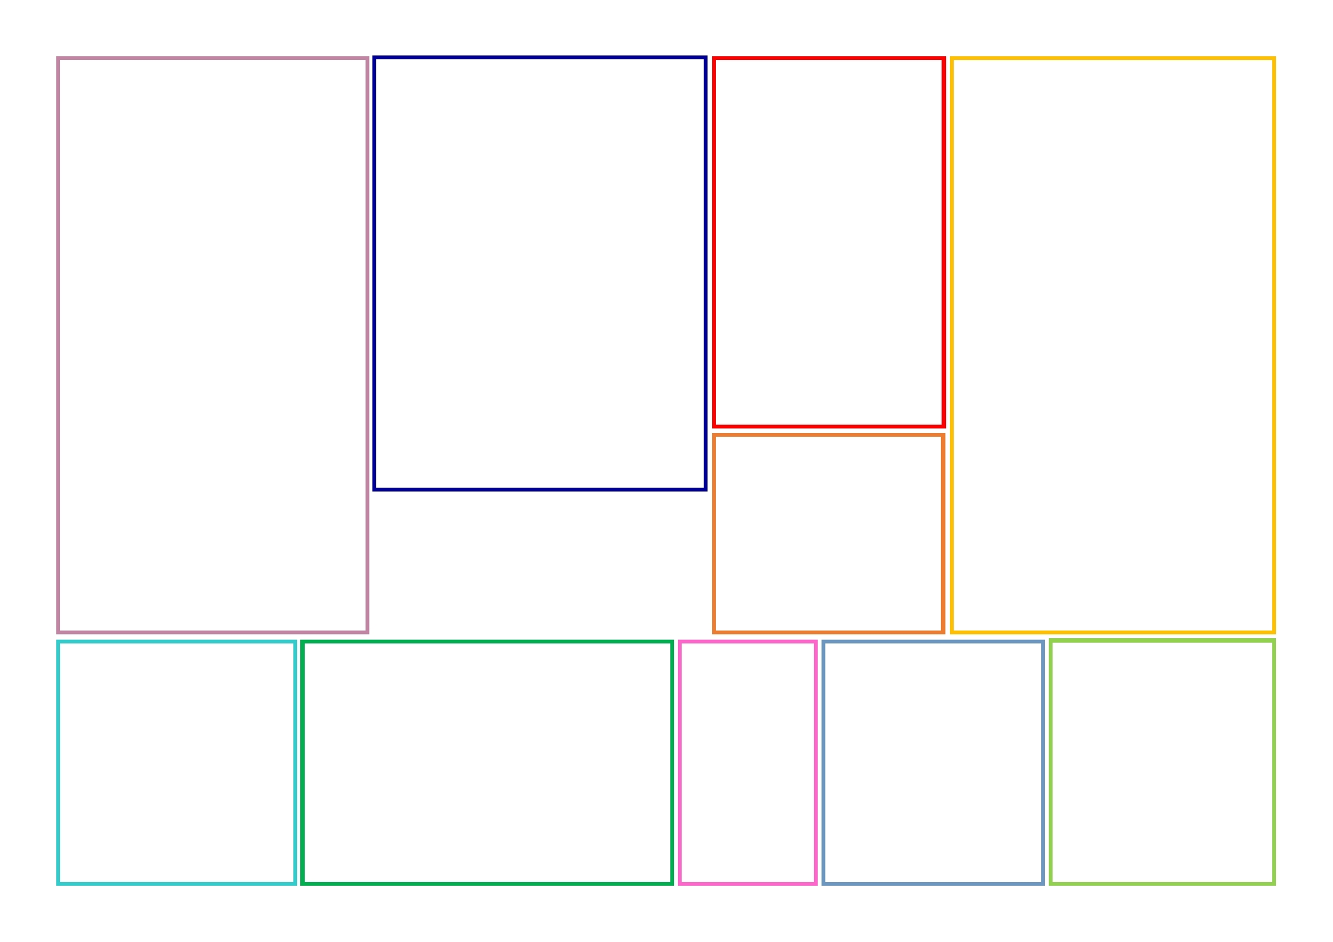
English
English this half term will focus on the tale of ‘The Tiger who came to tea’ by Judith Kerr. We will explore the settings and characters as well as story sequencing.
We will explore a variety of text types within this text. Writing invitations, letters and finally a story in a familiar setting.

We will be looking at exploring and developing our use of language to describe and focussing on our sentence structure. Everyone loves a perfect sentence!

In English we willl also we looking at our reading skills in daily reading sessions.

Geography y/ History

In our topic this half term we will be thinking about the beautiful area we live in and what it is like. We will get to explore map symbols and really think about what there is to see and do in Cumbria.

Pupils will become familiar with the terms Human and Physical features along with simple map symbols of importance. They will then get to try their hand at creating their own maps of the school and immediate surrounding area.

We will also be thinking about the produce that can be grown locally and used to reduce our carbon footprint.

Our Locality and us – Year 1
Autumn 1
Art / DT
In Art, we will be looking at portraits and thinking about how to draw with scale and proportion in mind.

We will also get the chance to create our produce using locally sourced foods.

PE
This half term, we will be developing out spacial awareness, ability to change direction and control movement through golf.
Math
This half term we will start by looking at place value, developing our knowledge of number and how it is represented. We will be expanding our knowledge of basic number 0-20 and building upon what we know. Counting one more and one less from any given number. Looking at tens and ones and how they make up a whole number.

We will continue to work on knowing both the name and spelling of each digit. We will also continue to develop our recall of number bonds to 10.
.

French

In French, we will develop some basic greetings.

Science

In Science, we will be looking at the ways in which we can look after ourselves. How do we make sure we are healthy and happy? What can we do to make sure we stay healthy?
We will be exploring healthy lifestyles and how what we choose to eat effects our bodies over time.

Computing
In Computing,
our focus will
be on coding and how we can use programmable toys.

Music
We will be exploring the use of our voices, rhythms and patterns in music.

RE
In religious education, we will be studying the beliefs of different cultures and the creation of the world. We will also be looking at what we can do to help protect and look after the planet.

